EXPERIMENT–1
IoE Sensor Data Acquisition and Preprocessing using Python in Google Colab

ABISHEK DEVARAJ
192512126

AIM:
To acquire IoE sensor data, perform preprocessing techniques such as handling missing values, removing duplicates, detecting outliers, normalizing data, and preparing the dataset for AI/ML applications using Python in Google Colab.

OBJECTIVES
- Understand IoE datasets.
- Import data.
- Handle missing values.
- Remove duplicates.
- Detect outliers.
- Normalize data.
- Visualize data.
- Prepare for ML.
THEORY
The Internet of Everything (IoE) integrates people, processes, data and things. Sensor devices continuously generate data such as temperature, humidity, pressure, CO₂ concentration and soil moisture. Raw data may contain missing values, duplicate records and abnormal readings. Data preprocessing improves the quality, consistency and reliability of the dataset before applying Artificial Intelligence and Machine Learning algorithms

Software Requirements
- Google Colab
- Python 3
- Pandas
- NumPy
- Matplotlib
- Seaborn
- Scikit-learn

Algorithm
- Start Google Colab.
- Import libraries.
- Upload dataset.
- Load CSV file.
- Display dataset.
- Check and fill missing values.
- Remove duplicate records.
- Detect outliers.
- Normalize numeric values.
- Visualize data.
- Save cleaned dataset.
Python Program
# Step 1: Import Required Libraries
import pandas as pd
import numpy as np
import matplotlib.pyplot as plt
import seaborn as sns
from sklearn.preprocessing import MinMaxScaler
# Step 2: Upload Dataset
from google.colab import files
print("Upload sensor_data.csv")
uploaded = files.upload()
# Step 3: Load Dataset
df = pd.read_csv("sensor_data.csv")
# Step 4: Display Dataset
print("\nFirst 5 Records")
print(df.head())
print("\nDataset Information")
print(df.info())
print("\nDataset Shape")
print(df.shape)
# Step 5: Check Missing Values
print("\nMissing Values")
print(df.isnull().sum())
# Step 6: Fill Missing Values with Mean
df.fillna(df.mean(numeric_only=True), inplace=True)
# Step 7: Remove Duplicate Records
duplicates = df.duplicated().sum()
print("\nDuplicate Records:", duplicates)
df.drop_duplicates(inplace=True)
# Step 8: Detect Outliers using IQR
print("\nChecking Outliers")
numeric_cols = df.select_dtypes(include=np.number).columns
for col in numeric_cols:
Q1 = df[col].quantile(0.25)
Q3 = df[col].quantile(0.75)
IQR = Q3 - Q1
lower = Q1 - 1.5 * IQR
upper = Q3 + 1.5 * IQR
outliers = df[(df[col] < lower) | (df[col] > upper)]
print(f"{col}: {len(outliers)} Outliers")
# Step 9: Normalize Numeric Data
scaler = MinMaxScaler()
df[numeric_cols] = scaler.fit_transform(df[numeric_cols])
print("\nNormalized Dataset")
print(df.head())
# Step 10: Plot Temperature Graph
plt.figure(figsize=(8,5))
plt.plot(df['Temperature'], marker='o')
plt.title("Normalized Temperature Sensor Readings")
plt.xlabel("Sample Number")
plt.ylabel("Temperature")
plt.grid(True)
plt.show()
# Step 11: Box Plot
plt.figure(figsize=(8,5))
sns.boxplot(data=df[numeric_cols])
plt.title("Boxplot of Sensor Data")
plt.xticks(rotation=45)
plt.show()
# Step 12: Histogram
df[numeric_cols].hist(figsize=(12,8))
plt.suptitle("Histogram of Sensor Values")
plt.show()
# Step 13: Correlation Heatmap
plt.figure(figsize=(8,6))
sns.heatmap(df.corr(numeric_only=True),
annot=True,
cmap='coolwarm',
linewidths=0.5)
plt.title("Correlation Heatmap")
plt.show()
# Step 14: Save Cleaned Dataset
df.to_csv("clean_sensor_data.csv", index=False)
print("\nCleaned dataset saved as clean_sensor_data.csv")
# Step 15: Download Cleaned Dataset
files.download("clean_sensor_data.csv")
print("\nExperiment Completed Successfully!")
OUTPUT :
S.no | Temperature | Humidity | pressure | Co2 | LightIntensity | SoilMoisture
1 | 0.11111 | 0.17777 | 0.90000 | 0.058824 | 0.083333 | 0.090909
2 | 0.166666 | 0.2222 | 0.8500000 | 0.078431 | 0.1333 | 0.14545
3 | 0.22222 | 0.266666 | 0.80000 | 0.098039 | 0.1666 | 0.1818
4 | 0.27777 | 0.3333 | 0.75 | 0.117647 | 0.200 | 0.21818
5 | 0.33333 | 0.3777 | 0.7000 | 0.1372549 | 0.25 | 0.2727
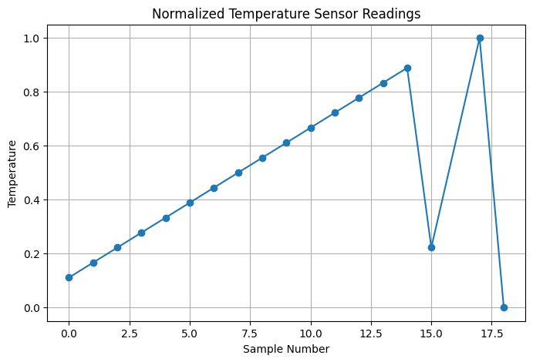

RESULT:
The IoE sensor dataset was successfully preprocessed and prepared for AI/ML applications.

